Projet F
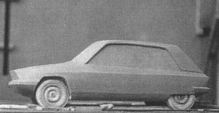 | Project F (also known as Projet AP) was to have been the definitive middle range Citroën, conceived in three versions - one powered by a flat four, air-cooled one litre, one by a 1600 cm3 transverse mounted water cooled unit derived from the DS engine and the third by a Wankel rotary engine.  The Wankel would have had hydropneumatic suspension and powered disc brakes while the four cylinder would have had conventional mechanical suspension.
Design work started in the early sixties following the decision to abandon Projet C .  While the use of advanced techniques such as front wheel drive and hydropneumatics had been enough to put Citroën at the forefront of automotive technology during the preceding thirty years, it was felt that something new was required if the company were to maintain its reputation. That something was the Wankel rotary engine and a joint venture was set up with NSU to build the powerplants. | 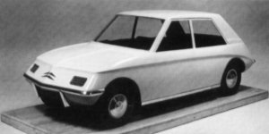
Flaminio Bertoni was responsible for the body design but unfortunately he died in 1964 leaving newcomer Robert Opron to complete the exercise.
A number of innovations were to be found - this would have been the first hatchback, the door frames were welded to the roof in much the manner used by the yet to be released Renault 16 and the use of four headlamps behind a glass panel anticipated the SM's styling.
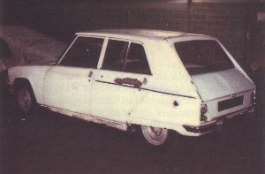 | 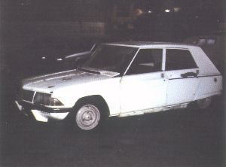
Unfortunately, the Wankel engine proved to be unreliable, there were problems with body rigidity, the two versions differed in length from one another, the conventionally sprung vehicle suffered too great a variation in ride height between unladen and laden states and there were problems with road holding and handling.
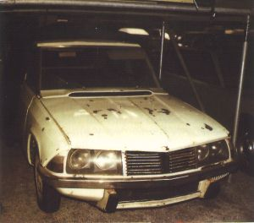 | 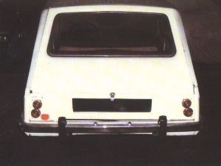
The Panhard PL17 (right), sold by Citroën dealers, was viewed as a stopgap solution to the lack of an intermediate model.  By the mid sixties though, the need for a product in what was becoming an increasingly popular and profitable market sector had become pressing. | 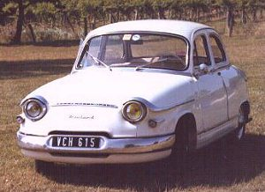
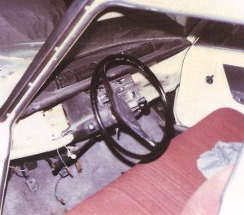 | 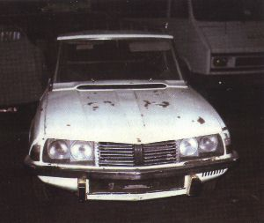
Work on this project reached an extremely advanced stage and then Renault launched the almost identically styled 16. Rumours of industrial espionage abounded but were unproved.  To add insult to injury, the technique for welding the roof and door frames had been patented by Renault.  This must be seen in the light of Renault's blatant plagiarism of the 2 CV with their 4 .  The project was dropped - millions of Francs were written off and work commenced on project G - the GS .  Projet F proved to be a costly exercise for Citroën. Presses had been ordered from Budd in the USA and had to be paid for. The failure of this project had ramifications for the company that led to compromises in both the technologies used and in the model range that eventually led to the financial crisis of 1974 and the acquisition of the company by Peugeot.
  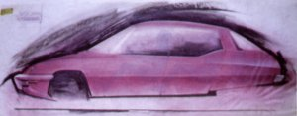
  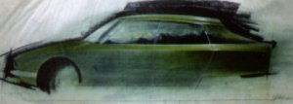
  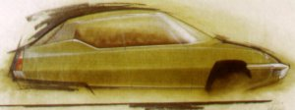
  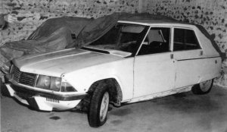
Having decided to abandon F, the company concentrated on the development of the SM and entered into a marriage of convenience with Fiat whose Autobianchi range was sold by Citroën dealers in France, thereby helping to widen the product range.
Above right - three design studies by Michel Harmand for the F - the rear wing/roof pillar junction was to be adopted in the SM .
As mentioned earlier, Project F would have been equipped with a Wankel rotary engine and as part of the test regime for that engine, a couple of hundred hydropneumatically suspended Ami coupes were built for testing by a selected number of high mileage motorists.  The M 35 was also as a test bed for the hydraulics employed in Project G . Unlike many prototypes, the M 35 was available for all and sundry to view. | 